EXPT NO:6 | IMPLEMENTATION OF MULTIVARIATE DISPLAYS
DATE: 24.01.2026 | IMPLEMENTATION OF MULTIVARIATE DISPLAYS

PRE-LAB QUESTIONS
- Why are multivariate displays important in AI analytics?
Multivariate displays allow AI analysts to visualize and understand relationships among multiple variables simultaneously. They help identify hidden patterns, correlations, and anomalies in complex datasets, supporting better feature selection, data interpretation, and informed decision-making.
- How do parallel coordinates differ from scatter plots?
Parallel coordinates visualize multiple variables across parallel axes, enabling comparison of many dimensions at once. Scatter plots display relationships between only two variables, making them simpler but limited for analyzing high-dimensional data.
- What challenges exist in interpreting multivariate plots?
Multivariate plots can become visually complex and cluttered as dimensions increase. Overlapping lines or points may reduce readability, making patterns difficult to interpret without proper scaling, labeling, or interactive filtering techniques.
- Where are trellis displays commonly used?
Trellis displays are commonly used in business analytics, healthcare, finance, and AI research to compare variable relationships across categories such as regions, time periods, or customer groups using small multiple panels.
- How does multivariate visualization aid model evaluation?
Multivariate visualization helps evaluate models by revealing feature interactions, error patterns, and performance variations across subsets of data. It supports diagnosing bias, overfitting, and understanding how different variables influence model predictions.

OBJECTIVE : To implement advanced multivariate displays for complex data analysis.

SCENARIO A retail analytics firm studies sales, profit, customer segment, and region to optimize business strategy.

IN-LAB TASKS (Using R Language) • Create parallel coordinate plots • Generate bubble charts • Implement trellis displays by region

CODE:
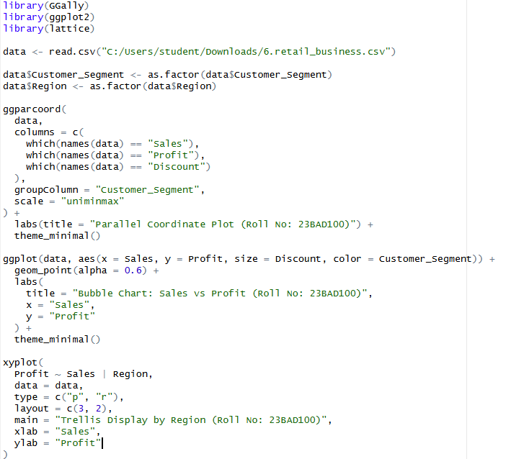

OUTPUT:
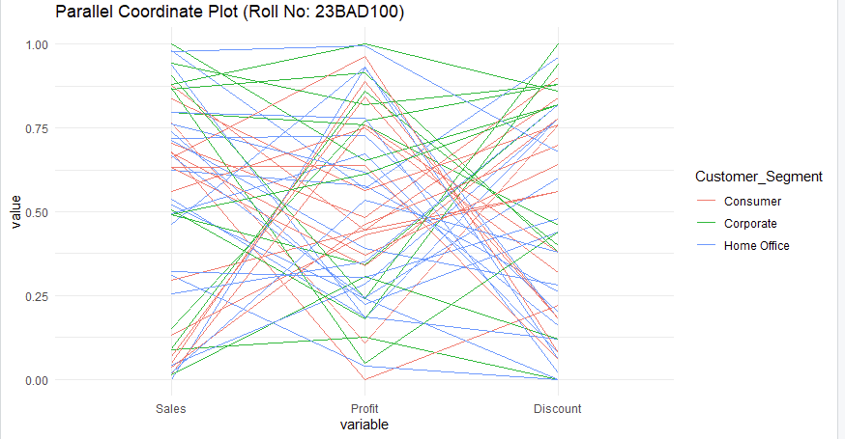
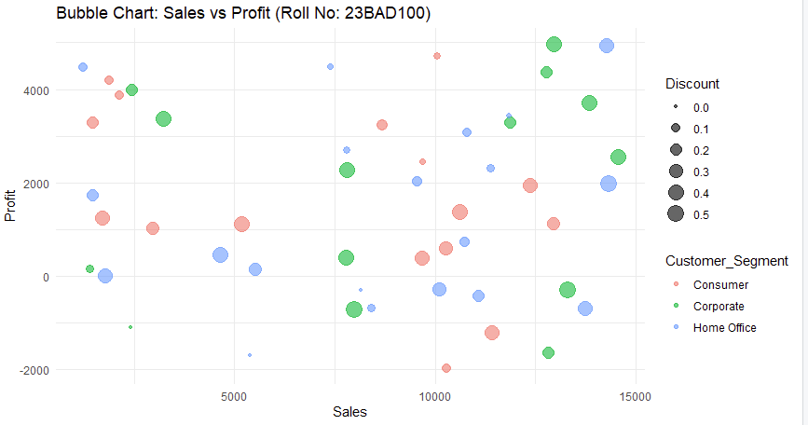
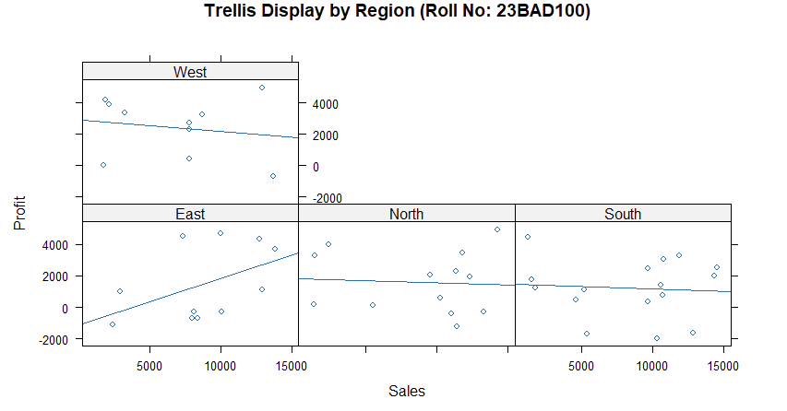
POST-LAB QUESTIONS
- What insights are gained from parallel coordinates?
Parallel coordinate plots reveal relationships, trends, and patterns across multiple variables simultaneously. They help identify clusters, correlations, and outliers in high-dimensional data, enabling better understanding of how variables interact across different categories or groups.
- How does faceting simplify complex data?
Faceting divides complex data into smaller, comparable panels based on categories. This separation reduces visual clutter, improves clarity, and allows easy comparison of patterns and trends across different groups such as regions or customer segments.
- What limitations exist in bubble charts?
Bubble charts can become difficult to interpret when many data points overlap. Variations in bubble size may be misleading, and exact value comparison is challenging, especially when data ranges are wide or poorly scaled.
- How can these displays support AI-driven recommendations?
These displays help identify user behavior patterns, feature importance, and segment-based trends. Visual insights assist AI systems in refining recommendation rules, improving personalization, and making data-driven decisions more interpretable and reliable.
- Suggest improvements for large multivariate datasets.
For large datasets, interactive visualizations, dimensionality reduction, filtering, and aggregation techniques can improve clarity. Using clustering, normalization, and color encoding helps manage complexity and enhances meaningful pattern discovery.

LEARNING OUTCOME: Students apply multivariate visualization for business intelligence.

ASSESSMENT
Description | Max Marks | Marks Awarded
Pre Lab Exercise | 5
In Lab Exercise | 10
Post Lab Exercise | 5
Viva | 10
Total | 30
Faculty Signature

